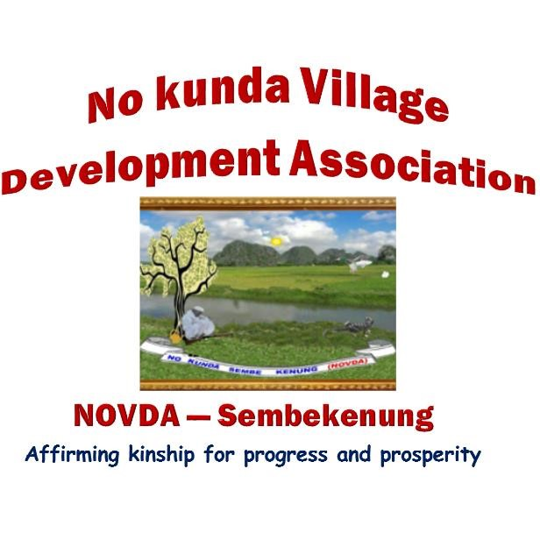
NOVDA SEMBEKENUNG BY-LAWS
Section 1
PLATFORM ADMINISTRATION (PLATFORM MANNERS, PRONOUNCEMENTS AND POSTINGS)
  - NOVDA Sembekenung shall for the purposes of effective communication open and administer platforms on Social media (WhatsApp, Telegram, etc.).
  - All such platforms shall be named NOVDA Sembekenung, with alphabetical variations for purposes of clarity and differentiation (e.g. NOVDA Sembekenung A, B, C, etc.).
  - All NOVDA Sembekenung platforms shall operate in strict accordance with the rules and regulations of the association as enshrined in the constitution or any by-laws designed for the purpose.
  - Membership of the platforms shall constitute the people of No Kunda or such people as are deemed eligible by the Chairman/Central Committee due to their relationship with the association or by reason of marriage to a citizen of No Kunda in-so-far as the individual concerned is interested.
  - Members' participation on the platforms shall be governed by the code of conduct of the NOVDA Sembekenung Platforms Administration.
  - The platforms shall be used to sensitise members to raise funds; disseminate public interest information (for the benefit of members) as well as promote the culture, traditions and faith of members.
……………………………..
Dr Lang Fafa Dampha
Chairman NOVDA Sembekenung

